SAMPLE FUNDRAISING LETTER/EMAIL

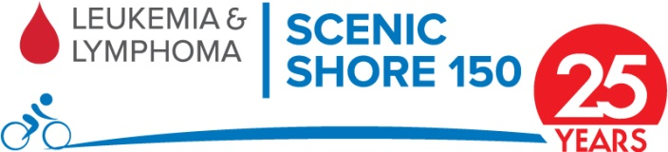

[Date]

Dear [family member or friend’s name]:

I am participating in the Leukemia & Lymphoma Society’s (LLS) Scenic Shore 150 Bike Tour on July 22-23, 2017, and I would like to ask for your support.

As you may know, [insert your personal reason for riding here – if you are affected by a blood cancer or have a family member affected, please share information about the diagnosis, treatment and why this ride is important to you.]

Nearly 40% of all FDA approved cancer drugs in the past decade were first approved for a blood cancer. Many are now being tested for other cancers and other illnesses. LLS is the single largest nonprofit contributor to blood cancer research – more than $1 billion has been invested in life-saving research.

Blood cancers are the number-three killer in the U.S. behind lung and gastrointestinal. LLS invests funds to accelerate innovative, life-saving treatments and patients aren’t just surviving, they’re living. Since the 1960’s, the five-year survival rate for many blood cancer patients in North America has doubled, tripled or even quadrupled.

LLS provides complimentary information and support to patients and their caregivers. Additionally, to help patients during this time of crisis, LLS’s financial aid and co-pay programs are critically important.

The Scenic Shore 150 Bike Tour is a very special weekend dedicated to celebrating and commemorating lives touched by cancer.

Your help will make a difference! Please consider making a donation to LLS on my behalf. To join me in the ride or to donate online, visit [insert fundraising page URL].

Thank you for your support in the fight against blood cancer.

[Your Name]
[Your Information and your website link]

